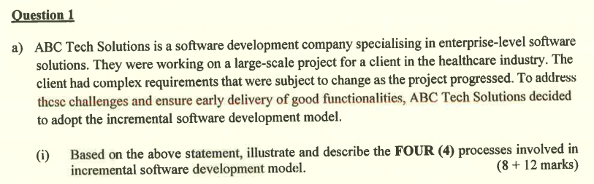

C2: Software Process Model (Incremental Model)

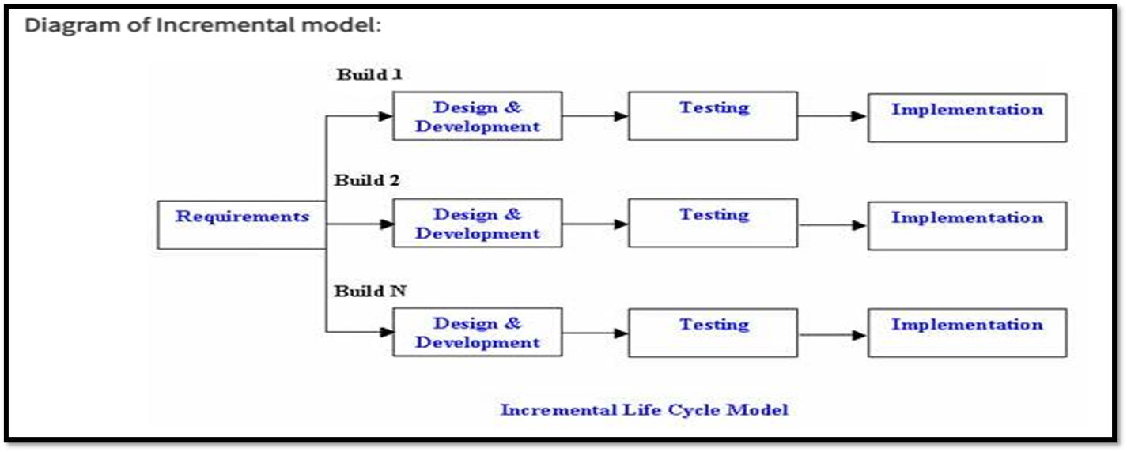

- Requirements
  - The system requirements will be collected at this stage to decide the main objectives of the software.
  - The development will start only after the sufficient requirements are gathered.
- Design and development
  - In the first build, the design and development will focus on the core functionalities and design to offer basic functionalities.
  - For the subsequent increment build, more features and functionalities will be developed and designed.
- Testing
  - The new features will be tested in every build to ensure that there are no errors or bugs before allowing the software to be deployed into the production environment.
  - The testing will also ensure that all the available functionalities are operating well.
- Implementation
  - The new functionalities or features will be deployed into the real-life use cases after every new features’ testing phase to provide a more complete and functional system.



- It can quickly generate a working software.
- It is flexible as it can easily adapt to requirement changes with low cost.
- It allows customer to respond to each built.
- The testing and debug can be easily done during small iteration.
- It has low delivery cost.
- The risk is easily to be managed as it can identify and handle all the errors and bugs during each iteration.



- Stimuli: Student registration success
Response: Display successful registration message on the screen

- Stimuli: Class schedule is finished arranged
Response: Send class schedule arrangement notification to users’ email

- Stimuli: Tuition class is started
Response: Display reminder notification to remind for taking attendance

- Stimuli: Tuition fee payment success
Response: Display successful payment message and navigate user to payment history page

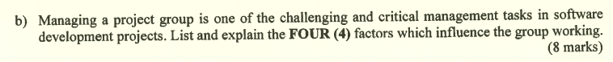

- Group composition
  - It determines whether the team has balance and right skills, experience and personalities.
  - For example, task-oriented, self-oriented and interaction-oriented.

- Group cohesiveness
  - It determines the way to promote group cohesiveness.
  - It can be achieved via establishing group identity, conducting team building activities and treating employees as responsible and trustworthy.

- Group communication
  - It determines whether all the project group members have effective communication between each other.

- Group organization
  - It determines whether the team is organized in a way that all the group members feel valued and satisfied with their current assigned roles.
  - A good group organization can be achieved via assigning a right job to the right person.

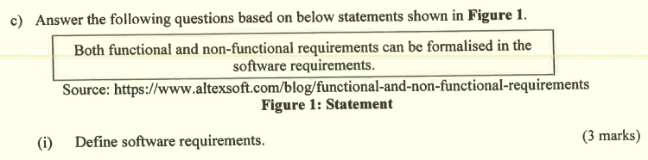

- Software requirements are complete specifications and descriptions of the software which should be fulfilled to achieve successful development of the software system.

- It includes official statements, system requirements and user requirements.

- Functional requirements
  - It is the statement of services which should be provided by the software.
  - It determines how the software should react to the particular input.
  - It determines how the software should behave in a particular situation.
  - It determines what the software should not do.

- Non-functional requirements
  - It applies constraints into requirements.
  - There are 3 types of requirements:
    - Product requirements
      - It is the result needed from the delivered product to behave in a particular way.
    - Organizational requirements
      - It is the consequences from the organization policies and procedures.
    - External requirements
      - It arises from the factors external to the system and its development process.

- Functional requirement
  - 1.0 Student Registration
1.1 System shall allow users to register as students via entering username, email, password and other personal information.

- Non-functional requirement
  - 1.0 Reliability
1.1 The tolerated downtime error of the system must be below 0.01% every year.

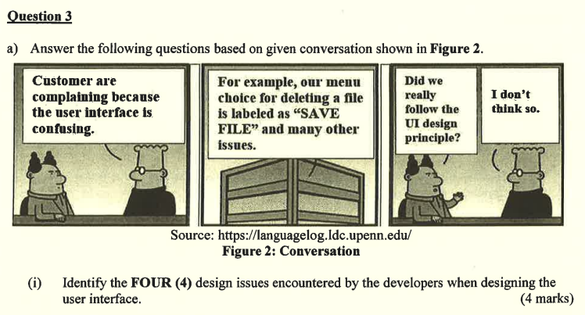

- It is difficult to decide the way for users to provide information to the system.

- It is difficult to decide the way for the system to present the information to the users. A wrong or ambiguous label may make the users confused and take an unwanted operation.

- The unfamiliar or improper uses of color indicators may easily bring a wrong meaning to the users and cause the subsequent wrong action taken by users.

- The inefficient color used for layout design may bring a negative impact to users’ readability on the user interface content.

- User familiarity
  - When designing the user interface of the system, the developers should refer to the design layout of other existing and popular system which provides the similar functionalities.
  - They can take the ideas from the existing systems design and apply it into their own system via improving or innovating it.
  - Thus, it can bring a sense of familiarity to the users. They can easily master the new system based on their experiences of dealing with other similar systems.

- User guidance
  - The system should provide sufficient help facilities or provide sufficient feedback on users’ action.
  - The system can provide a help button on the top right corner at main page. When the users have no idea about how to deal with the system, they can click on the help button to understand how to operate the system clearly.
  - The system should also display the error messages on time when users have made some mistakes or invalid input such as entering invalid characters when filling the registration form.

- User diversity
  - The system should provide different functionalities and features for different types of system users.
  - When considering novice and expert users, the developers should provide two different methods but both of them achieve the same operation. For novice users, they can provide buttons, dropdown list or checkboxes with meaningful labels for users to execute the actions. For expert users, they should allow users to enter shortcut keys using keyboards to execute the same actions.
  - For novice users, the way to execute actions is understandable but takes more time. For expert users, the way to execute actions is very efficient and immediate but there is a lack of information as expert users already know what and how they want to do.

- Consistency
  - The developers should decide a user interface design standard and apply it to every pages if possible.
  - This can effectively reduce users’ learning time and cost for accessing every single page.
  - Once users have learnt how to deal with one of the system user interface page, they can apply the same recognition and experience on other pages without relearning the operation of other pages.

- Minimal surprise
  - The behavior of the system should never surprise the users.
  - The system should provide sufficient and meaningful feedback and response to every users’ actions or any situation.
  - When users have made the payment successfully, the system should display a payment successful message instead of directly kick the users out from the payment page without any notification or feedback.

- Recoverability
  - The system should allow users to recover from errors.
  - When the users have made mistakes such as entering a wrong nickname in the registration page, the system should allow users to modify their nickname and re-enter the correct nickname afterwards.

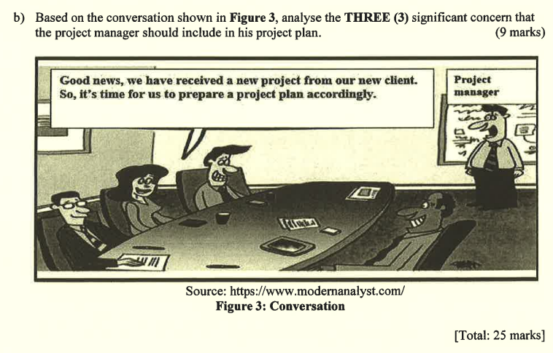

- Planning
  - The project objectives, deliverables and requirements should be decided before starting the development process.

- Scheduling
  - It includes scheduling the project management. It may use a gantt chart to plan the timeline for each main task and subtasks.
  - Thus, all the tasks can be done within the specified time range and the project can be finished before the deadline.

- Supervise
  - It refers to supervising the work to ensure that all the tasks are carried out based on the required standards.
  - Thus, productivity and effectiveness can be promised.

- Monitor progress
  - It refers to checking whether the development is on time and within budget.

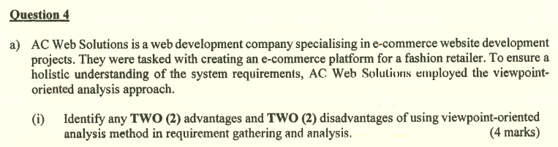

- Advantages
  - Multiple perspectives
    - Viewpoint-oriented analysis method can capture the needs and requirements from different stakeholders or user groups to ensure a comprehensive coverage.

  - Improve communications
    - It can facilitate better communication between developers and stakeholders by focusing on specific viewpoints.

- Disadvantages
  - Time-consuming
    - Viewpoint-oriented analysis methods will spend more time on gathering and analyzing requirements from multiple viewpoints.

  - Complexity
    - It has to manage a large number of viewpoints and conflicting requirements may add complexity to the process.

- Interactor viewpoints
  - Fashion retailer
  - Online client
  - Sales staff

- Indirect viewpoints
  - Manager
  - Supplier
  - Shop owner

- Domain viewpoints
  - UI Standard

(Draw viewpoint hierarchy)

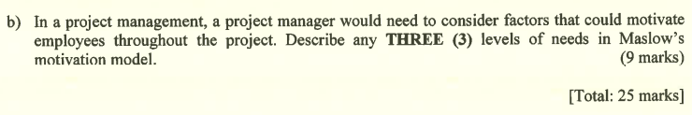

- Physiological needs
  - This level prioritizes offering the fundamental needs to the employees so they can continue to survive.
  - For example, the company should provide water, food and sufficient break time for users to energize themselves.

- Safety needs
  - This level focuses on providing a safe working environment and promised job security to employees.
  - For example, the company should ensure that the working place is stable, safe and comfortable for employees to work.

- Belongingness and love needs
  - This level focuses on establishing a healthy relationship between employees and their family members, friends and even colleagues.
  - For example, the company should allow employees to have freedom and effective communication between each other in the company area. The company can also conduct team building events regularly to enable employees to foster healthy relationships and collaboration ability between each other.

